Attribute Categories, Attributes & Picklist Values
Business Scenario
Company: ABC Solutions (enterprise hardware reseller)
Requirement: Sales reps need to configure a "Business Laptop Pro" product during quoting - selecting processor, RAM, storage, and color - with each combination visually organized and priced correctly in the CPQ configurator.
Solution components built in this use case:
Component | Example
Product | Business Laptop Pro
Attribute Category | Hardware Specifications, Software & Warranty
Attributes | Processor Type, RAM Size, Storage Capacity, Laptop Color
Picklists | Processor Options, RAM Options, Storage Options, Color Options

Build order: Attribute Category → Picklist & Picklist Values → Attribute (links both) → Assign Attribute to Product
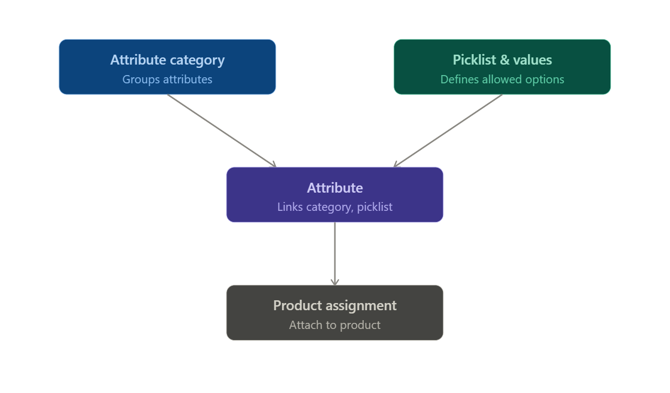

An Attribute Category is a grouping container for related attributes. It controls how attributes are visually organized and sectioned when a rep configures a product in the Revenue Cloud UI.
Ex.
1)
Field | Value
Category Name | Hardware Specifications
Code | HW_SPEC
Description | Groups hardware-related configuration attributes for laptops

2)
Field | Value
Category Name | Software & Warranty
Code | SW_WAR
Description | Groups software-related configuration attributes for laptops

Picklists & Picklist Values
A Picklist is a reusable, predefined set of values that gets attached to a picklist-type Attribute. Picklist Values are the individual selectable options within that picklist (e.g., "8GB," "16GB," "32GB").
Ex.
Picklist Name | Code | Values
Processor Options | PROCESSOR_OPTIONS | Intel i5, Intel i7, Intel i9
RAM Options | RAM_OPTIONS | 8GB, 16GB, 32GB
Storage Options | STORAGE_OPTIONS | 256GB SSD, 512GB SSD, 1TB SSD
Color Options | COLOR_OPTIONS | Silver, Space Gray, Black

Attributes
An Attribute is an individual configurable characteristic of a product (e.g., "RAM Size"). It has a data type - Picklist, Text, Number, Checkbox, or Date — and, when picklist-based, links to one of the picklists. It also gets tagged to an Attribute Category.
Ex:
Attribute Name | Code | Data Type | Category | Picklist Used | Required
Processor Type | PROCESSOR_TYPE | Picklist | Hardware Specifications | Processor Options | Yes
RAM Size | RAM_SIZE | Picklist | Hardware Specifications | RAM Options | Yes
Storage Capacity | STORAGE_CAPACITY | Picklist | Hardware Specifications | Storage Options | Yes
Extended Warranty | EXT_WARRANTY | Checkbox | Software & Warranty | — | No

Product Classification
A Product Classification is a reusable template that bundles a set of dynamic attributes; assigned either individually or by Attribute Category. Any product linked to that classification automatically inherits the whole attribute set, instead of attributes being re-added product by product.
Classification vs. Category vs. Catalog
These three sound similar but do different jobs:
Object | Purpose
Product Classification | Attribute template - what a product can be configured with
Product Category | Catalog navigation hierarchy - where a product sits (e.g., Electronics → Computers → Laptops)
Product Catalog | Top-level container organizing categories, often per sales channel or business unit

Step-by-step creation
- Go to Product Catalog Management (Revenue Cloud) → Product Classifications
- Click New
- Fill in:
Field | Value
Classification Name | Laptops
Code | LAPTOPS
Description | Standard configurable attribute template for all laptop products
- Save
- Open the Related tab → Attributes section → click Assign
- Choose Assign individual attributes or Assign by attribute category (category assignment is faster when the category already contains everything you need)
- Select the attributes/category → Next
- Set overrides for this classification if needed — e.g., check Is Price Impacting, set Is Required, set Sequence
- Click Save
Example classification for this use case
Classification: Laptops (Code: LAPTOPS)
Attribute | Category | Sequence | Required | Price Impacting
Processor Type | Hardware Specifications | 1 | Yes | Yes
RAM Size | Hardware Specifications | 2 | Yes | Yes
Storage Capacity | Hardware Specifications | 3 | Yes | Yes
Laptop Color | Hardware Specifications | 4 | No | No
Extended Warranty | Software & Warranty | 1 | No | Yes

Product Creation & Classification Assignment
The Product record (Product2) is the actual sellable item reps quote. Linking it to a Product Classification pulls in that classification's entire attribute template automatically.
Significance
This is the step where everything built so far - categories, picklists, attributes, classification - becomes a real, quotable catalog item.
Step-by-step creation
- Go to Products → click New
- Fill in the core fields:
Field | Value
Product Name | Business Laptop Pro
Product Code | LAPTOP-PRO-001
Product Family | Hardware
Description | Enterprise-grade configurable business laptop
Is Active | True

Product Catalog
A Product Catalog is the top-level container that holds all products and categories for browsing. It carries no pricing or configuration logic of its own — it exists purely to organize how products are grouped and presented, often per sales channel, business unit, or region.
Significance
- Single source of organization — everything a channel or business unit sells lives under one catalog
- Channel segmentation — a "Direct Sales Catalog" vs. a "Partner Catalog" can expose different subsets of the same product library
- Low-risk structure — unlike Product Classification, catalog membership doesn't change pricing or attributes, so restructuring later is safe
- Foundation for categories — every Product Category must belong to a catalog
Step-by-step creation
- Go to Product Catalog Management (Revenue Cloud) → Product Catalogs
- Click New
- Fill in:
Field | Value
Catalog Name | ABC Solutions Hardware Catalog
Code | HW_CATALOG
Description | Primary catalog for all hardware products sold by ABC Solutions' direct sales team
- Click Save
Example catalog for this use case
Catalog Name | Code | Purpose
ABC Solutions Hardware Catalog | HW_CATALOG | Houses all hardware products, including Business Laptop Pro, for the direct sales channel

Product Category
A Product Category is a node (or hierarchy of nodes) inside a catalog, used to group products for browsing and navigation — e.g., Electronics → Computers → Laptops. A product can belong to multiple categories.
Significance
- Findability — reps and self-service buyers navigate a curated hierarchy instead of scrolling a flat product list
- Filtering & search — categories power the browse/filter experience in the catalog UI
- Reusable structure — subcategories nest (Computers → Laptops) to match how the business actually thinks about its portfolio
- Dynamic visibility — categories can be shown or hidden per audience using qualification rules (e.g., hide "Enterprise Servers" from small-business buyers)

Step-by-step creation
- Go to Product Catalog Management → Product Categories
- Click New and create the top-level category:
Field | Value
Category Name | Computers
Code | COMPUTERS
Catalog | ABC Solutions Hardware Catalog
Parent Category | (blank — top level)
- Save
- Click New again and create the subcategory:
Field | Value
Category Name | Laptops
Code | LAPTOPS_CAT
Catalog | ABC Solutions Hardware Catalog
Parent Category | Computers
- Save
Example category hierarchy for this use case
ABC Solutions Hardware Catalog
└─ Computers
└─ Laptops

Product Selling Model
What it is
A Product Selling Model defines how a product is sold and billed - independent of what the product is or how it's configured. Revenue Cloud ships three core types:
Selling Model | Behavior | Example
One-time | Single payment, no recurrence | Laptop purchased outright
Term-defined | Subscription with a fixed end date | 12-month device leasing plan
Evergreen | Subscription that recurs until cancelled | Monthly device-protection plan
Significance
- One product, multiple ways to buy — "Business Laptop Pro" can be sold outright or leased over 12 months without creating duplicate product records
- Billing accuracy — the selling model drives how the Price Book Entry and downstream subscription/billing records behave
- Rep flexibility at quote time — reps pick the selling model per quote line to match what the customer wants
- Reusable across the catalog — the same One-time/Term-defined/Evergreen records are shared by many products, not rebuilt per product
Step-by-step creation
- Go to Product Catalog Management → Product Selling Models
- Click New and create the first model:
Field | Value
Selling Model Name | Laptop – One-Time Purchase
Selling Model Type | One-time
- Save
- Click New again and create the second model:
Field | Value
Selling Model Name | Laptop – 12-Month Lease
Selling Model Type | Term-defined
Pricing Term | 12 Months
- Save
Example selling models for this use case
Selling Model Name | Type | Term
Laptop – One-Time Purchase | One-time | —
Laptop – 12-Month Lease | Term-defined | 12 Months

Section J — Assigning Category & Selling Model to the Product
- Open the Business Laptop Pro product record
- Go to the Related tab → Categories section → click Assign
  - Select Laptops (the subcategory built in Section H) → Save
- Go to the Related tab → Selling Models section → click Assign (this creates Product Selling Model Option records)
  - Add Laptop – One-Time Purchase
  - Add Laptop – 12-Month Lease → Save
- For each selling model assigned, add a matching Price Book Entry:
Selling Model | List Price
Laptop – One-Time Purchase | $1,899
Laptop – 12-Month Lease | $175/month
- If your org requires it, sync pricing and rebuild the catalog index so the changes reflect in the runtime buying experience

End Result — What the Rep Sees
Before configuring attributes, the rep finds Business Laptop Pro by browsing ABC Solutions Hardware Catalog → Computers → Laptops, and picks a selling model — One-Time Purchase or 12-Month Lease. Then the CPQ configurator renders:
Section: Hardware Specifications
- Processor Type → Intel i5 / Intel i7 / Intel i9
- RAM Size → 8GB / 16GB / 32GB
- Storage Capacity → 256GB SSD / 512GB SSD / 1TB SSD
- Laptop Color → Silver / Space Gray / Black
Section: Software & Warranty
- Extended Warranty → checkbox

Best Practices
- Keep attribute and picklist codes consistent (e.g., SCREAMING_SNAKE_CASE) so they're easy to reference in rules and integrations
- Reuse picklists across products instead of duplicating them — a "Color" picklist should serve every product that needs color options
- Use categories once you have more than 3–4 attributes on a product; below that, a flat list is often clearer
- Plan attribute-based pricing and configuration rules at the same time you design attributes — retrofitting rules later is more error-prone
- Deactivate rather than delete picklist values that are no longer sold, to preserve historical quote/order integrity
- Build a Product Classification as soon as a product line has 2+ similar SKUs — the setup time saved compounds with every new product added later
- Keep the number of catalogs small — use categories to segment products within one catalog rather than creating separate catalogs, since catalog membership carries no pricing logic of its own
- Design Selling Models as shared, reusable records (One-time, Evergreen, Term-defined variants) once, and reference them across every product that needs those buying options — don't recreate them per product

